Computer Functions and the Operating System
Name of Student
Name of Institution
Date
- Identify purpose, functions, advantages and disadvantages of the following OS
- Microsoft Windows OS - The primary function of Microsoft Windows OS is provision of a platform that allows for the management of programs and native files (Madnick & Jonovan, 2011). Since it is the most widely used OS, it can work with a variety of computers, regardless of the manufacture line. However, most virus programs developed target the OS.
- Mac OS X - The principle function of the Mac OS X is to run the Mac and UNIX applictions on the Macintosh nd iMac computers. The OS is designed easthetically which makes it attractive and enjoys superior connectivity with Apple devices. However, its is more costly in comparison to Windows (Vermaat et al., 2014).
- Linux OS - Linux OS serves as a free and reliable open source operating system for embedded devices, servers, IoT devices, and desktops (Madnick & Jonovan, 2011), and is useful in writing and compiling programs for programmers. The OS is adapatble to old computers. However, the Linux OS is cumbersome to use.
- Android OS - The primary function of the Android OS is allowing for intuitive manipulation of mobile devices theough common motion interctions (Madnick & Jonovan, 2011). The OS is subject to frequent updates which enhance performance, runs on several devices, and can be downloaded from the internet. However, most applications on the OS require internet connection, and it tends to be slow when running multiple applications.
- iOS- The operating system allows the users of iPads, Apple televisions, and iPhones to interact with their machines through various gestures. The OS never slows does even whren running multiple applications concurrently and its design allows for high processing speed. The iOS, however, does not allow for USB storage and Bluetooth, and also requires payment for mot applications.
- Blackberry OS - The function of the Blackberry OS is powering Blackberry handheld devices. The OS is very fast, highly user-friendly, and offers functional connectivity. However, has poor application support.
- My File Management System
The ‘New Technology File System’ is the term applicable for the file management system on my computer (figure 1). The system is highly applicable for the storage and retrieval of files from the hard drive. The b-tree directory scheme is the strategy used in the tracking of file clusters, with each cluster holding information about its contents.
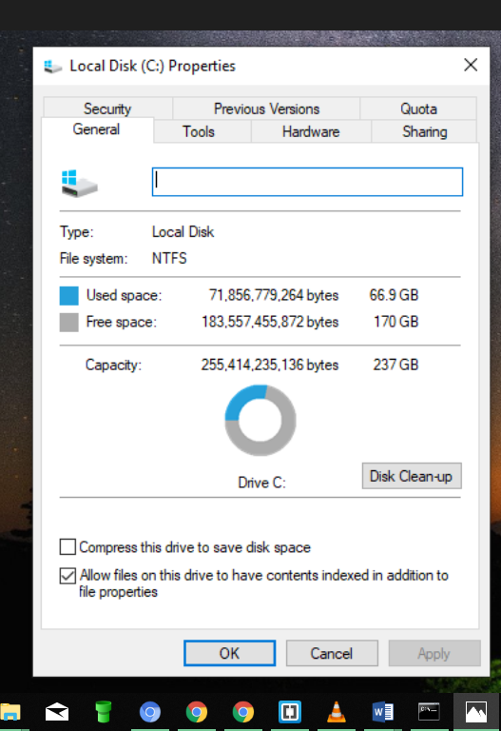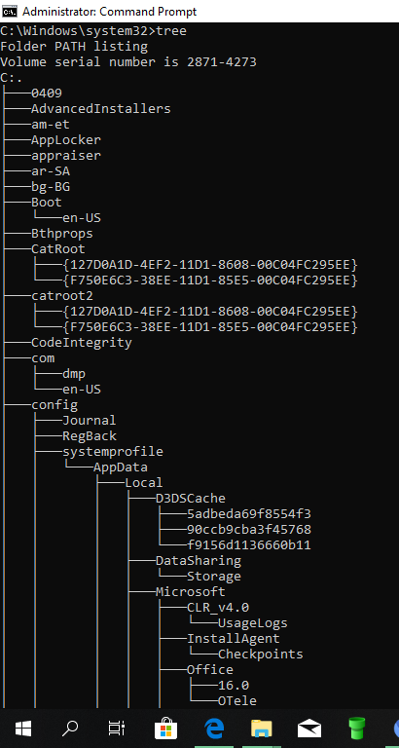
Figure 1 NTFS File System Figure 2 Screenshots of my computer file structure
- Explain the process and programs used to backup Mac OS and Windows
- Windows
‘Backup and Restore’ is useful in backing up to Windows OS. The program requires connection to an external storage device. The user may then click property on the drop down menu of the main drive and access the tools tab (vermatt et al., 2014). The backup windows tab offers a range of options inclusive of immediate, user-selected, and automatic backups according to the preference selected by the user.
- Mac OS
The ‘Time Machine’ is the applicable program for backing up files in Mac OS. After connection to an external storage, the computer will prompt whether to make use of Time Machine. However, lack of automatic pop up may require navigation to the System Preferences, where selection of the program and the disk will automatically begin the process. The program also deletes old back ups after completion.
- Explain the importance and functions of the following system utilities
- Disk Clean Up - The utility assesses the computer storage for files that are safe to delete, and deletes them to create space the user may also make use of the utility to select what to get rid off.
- Disk Defragmenter - The utility consolidates the files in a computer such that they consume lesser space, so as to increase speed and enhance performance.
- Disk Checking Utility – the utility scrutinizes and diagnoses mistakes and improper sectors on the harddrive, and resorts to corrective measures as safeguard from corruption.
- Discuss three common computer problems
The most prone risks for computers include Dynamic Link Library (DLL), Failure in installation of applications, and Blue Screen. The traits for the latter is a display of a blue screen displaying white lines of code. The problem arises due to hard drive problems, corrpted DLL files, hardware or software failure. The DLL serves as a warehouse and instructs the OS on mechanisms to run certain functions. Loss or corruption of such files is detectable by an error message on the computer when the user tries to run specific tasks. The failure to instal new programs to the computer may arise from lack of space.

References
Madnick, S. E., & Jonovan, J. J. (2011). Operating systems. New Delhi: Tata Mcgraw Hill Education Private.
Vermaat, M., Campbell, J. T., Freund, S. M., Frydenberg, M., & Sebok, S. L. (2014). Discovering Computers: Technology in a world of computers, mobile devices, and the internet: Essentials. Boston, MA: Course Technology, Cengage Learning.

